|  | United International University (UIU)Department of CSETrimester: Spring 2022Course Name: | CSI 424 | Simulation & Modeling Laboratory (Section A) |
| --- | --- |

## Submission Guideline:

* Please solve the problems in separate files (**One notebook/python file per task**).
* **Download the python files** as instructed in the class. (File -> Download -> Download .py)
* Create a new **folder** and put all your python files inside the folder.
* Rename the folder with your 9 digit student ID.
* Make a ZIP of the folder and **submit the .zip file**.

Please do not copy codes from others/the internet. Each of the offline assignments will be evaluated with a viva. You must be able to explain your code. Also, we will run a copy checker on the submissions. Any plagiarism will be severely penalized.

**Offline assignment 1**

1. **[5 marks]** Write a program that takes an integer input **n**. Then it will input **s**, which is a line containing some words. If **s** contains exactly **n** words, then it will do the following-

Print the words in separate lines and wrap all the texts with a rectangle made of asterisks (*). Make sure the right border of your rectangle is straight.

| **Input** | **Output** |
| --- | --- |
| 4  A cup of coffee | ********  *A *  *cup *  *of *  *coffee*  ******** |
| 3  Laughter is medicine | **********  *Laughter*  *is *  *medicine*  ********** |
| 4  I am fine | Word count mismatch. Try again!  *[Explanation: n is 4 but number of words in the given line is 3.]* |

1. **[5 marks]** See the figure below. We will estimate the value of π using this figure.

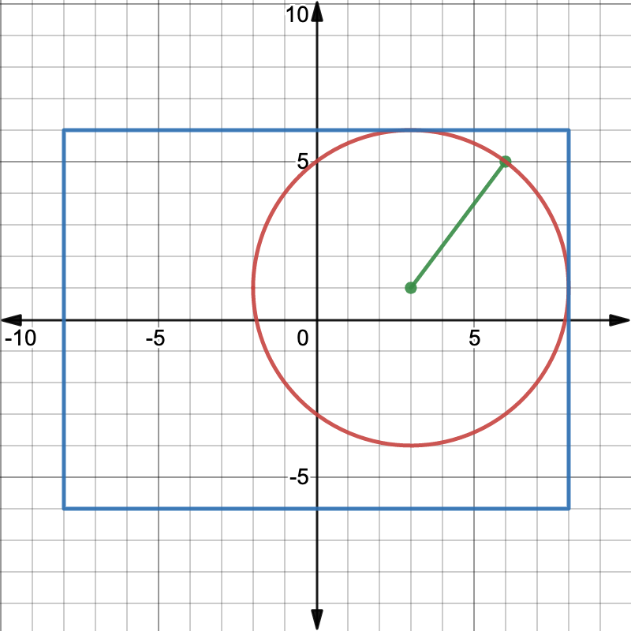

* **Task a)** If we randomly sample a point from the inside of the blue rectangle, what is the probability that the point will be inside the circle? Express this value in terms of π (pi). [Find this analytically using pen and paper]
* **Task b)** Simulate sampling 1000 data points and use the probability equation found from **Task a** to estimate the value of π.
* **Task c)** Make a scatter plot with your sampled data points. Mark points inside the circle red and outside the circle green.